

Qcam IP2M822E Quick Start Guide

Version 1.0.1
Welcome
Thank you for purchasing our Qcam IP2M822E!

This quick start guide will help you become familiar with our camera in a very short time.

Before installation and operation, please read the below safeguards and warnings carefully.
If you are still have further questions after reading this guide, please contact our support team by emailing support@qcam.com or by going to qcam.com/support.

Important Safeguards and Warnings
- All installations and operations here should conform to your local electrical safety codes.
- We assume no liability or responsibility for any of the fires or electrical shocks caused by improper handling or installation.
- We are not liable for any problems caused by unauthorized modifications or attempted repair.

Check Hardware
When you receive the camera in the packaging, unpack it, and check all sides of the camera for any physical damage. The protective materials used in the packaging of the camera can protect most accidental damage during transportation, but to ensure that your equipment is operating as expected, it is recommended to inspect the product before proceeding further.

On the camera unit, check specifically that the label on the side of the camera is not damaged. The serial number of the unit is often needed to provide support.

Please check that all required items for your camera are present and accounted for. To check what is included with your purchase, go to http://qcam.com, find the product,and scroll down and click the “What’s Included” tab. If any item is missing, please contact us as soon as possible so we can send you the missing component.

Note: Hardware does not look exactly as pictured in this section, but the steps to assemble the hardware are the same.

Setup Hardware
To setup the camera, connect it to the NVR as follows:

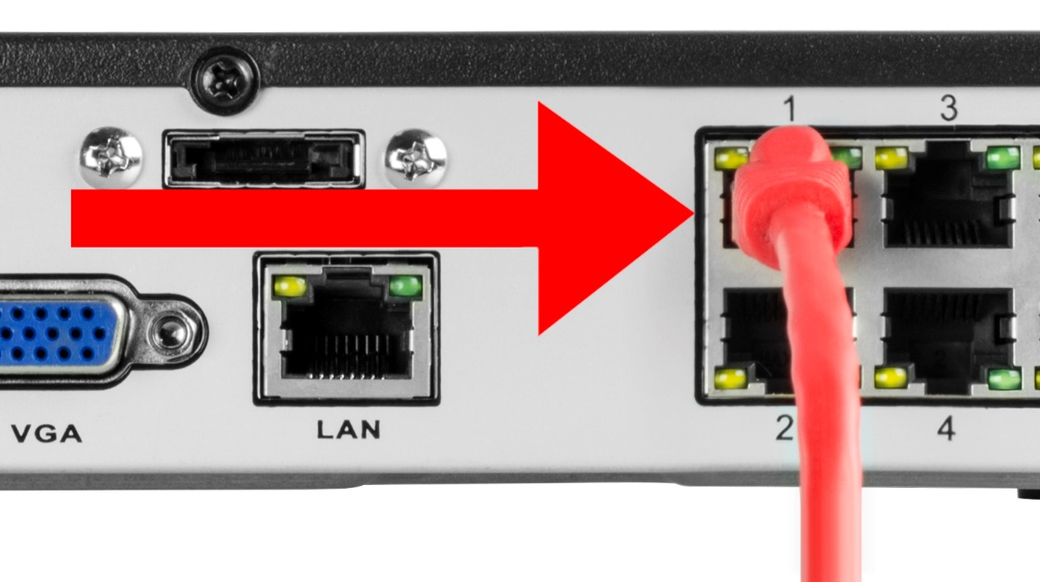
- Connect the Ethernet cable to a port on the back of the NVR.
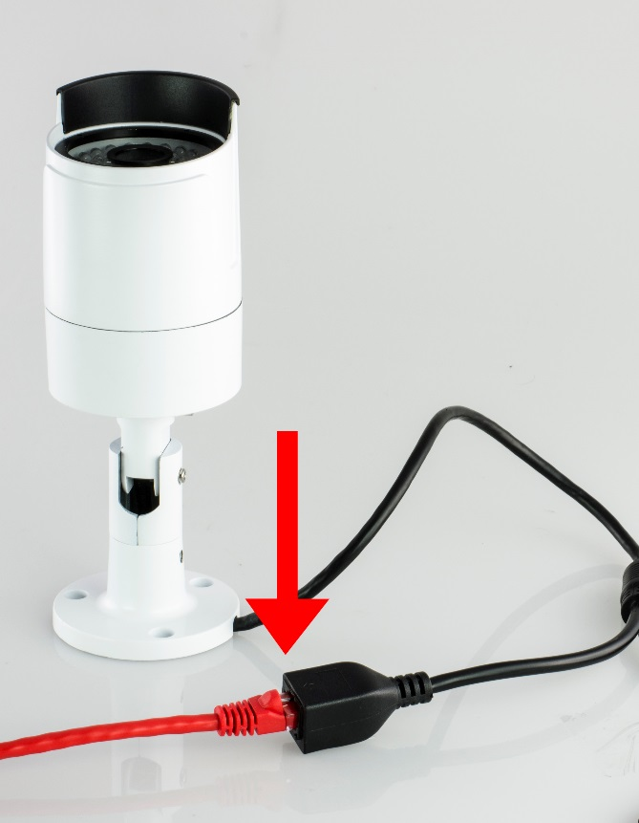
- Connect the camera cable to an Ethernet cable.

Hardware Setup Guidelines
- The internal components of the camera can be damaged by prolonged exposure to direct sunlight. Do not point the camera directly at the sun.
- The camera produces great images when it’s in the shade looking at subjects that are well lit. Do not place the camera in bright light and have it facing shade or darkness.
- Bright light sources to the sides of, or behind the subject will interfere with your images.
- The camera’s night vision will give well-exposed images if the area is dark. However, if there’s a bright point source in the camera’s view (a streetlight, car headlights, or anything similar) then night vision mode might not engage.
- Typically, the best view is obtained approximately 7ft (2m) to 10ft (3m) high, looking slightly downwards.
- The camera can be mounted onto a flat surface using screws. The surface must have sufficient strength to hold the camera. Materials such as hardwood, brick or masonry are good options, and we’ve included all the gear you’ll need to mount it there (except the tools - sorry, you’ll still need your own drill). You can mount the camera onto a metal surface, but you’ll need to supply your own mounting hardware.
- To mount the camera:
  - Position the camera in the location you want to mount it, and mark the screw holes on the surface to position the screws or attach the supplied mounting template on the surface. Then, using appropriate screws for the surface you’re fixing the camera to, secure the camera into place.
  - If you’re mounting to a wooden surface, then screw the camera directly to the surface.
  - If you’re mounting to a masonry surface (bricks, concrete or similar) then you’ll need to use the included wall plugs.
- To adjust the camera angle:
  - Using the supplied L-wrench or screw drivers, loosen the appropriate hex screws on the stand to pan, tilt or rotate the camera.
  - Remember to tighten the screws back securely to lock the camera’s position in place after you’ve finished adjusting the viewing angle of the camera.

Weather & Tampering
The camera’s casing is resistant to water, different weather conditions and tampering. It would take an overwhelming event of this kind to damage the housing of the camera (severe weather such as hurricanes or someone intentionally damaging the lens would be enough). However, the cable and connector are vulnerable and require protection.

Cable Management& Installation

- For best results, run the cable inside a wall cavity or other protected enclosure, and ensure that the network cable connection is safely sealed away from rain, direct sunlight and potential vandals.
- When plugging or unplugging the network cable, hold the plug portion of the cable. When unplugging, do not pull on the network cable but unplug while pressing down on the lock.
- Never place strain of any kind on the network cable connection. It’s designed to clip into place to prevent slippage, but it won’t support any weight and can be easily broken by a sharp tug. Exercise caution.
- Ensure that cables are sheltered from moisture, weather and sunlight. The network cable connection was designed and intended for indoor use with computer networking - while it’s ideal for handling the massive data loads that network cameras require, it’s not weatherproof.
- If you are installing the camera outside of your home, we highly recommend using waterproof tape to wrap the cable connection area between the camera’s Network (LAN) port and the extension cable’s Ethernet plug. Use as much as is necessary for the layer of tape to protect the connection. This will help prevent water or moisture from leaking into the cable which can cause the network cable connection to degrade over time or stop working.

Individual Camera Setup
- Ensure that the camera is connected to an NVR or a router that is on the same network as your PC.
- Install the software “smartClient” from the included CD, and after installation, run the program. The software icon on your desktop looks like this: 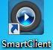
- The login interface looks like the screenshot below:
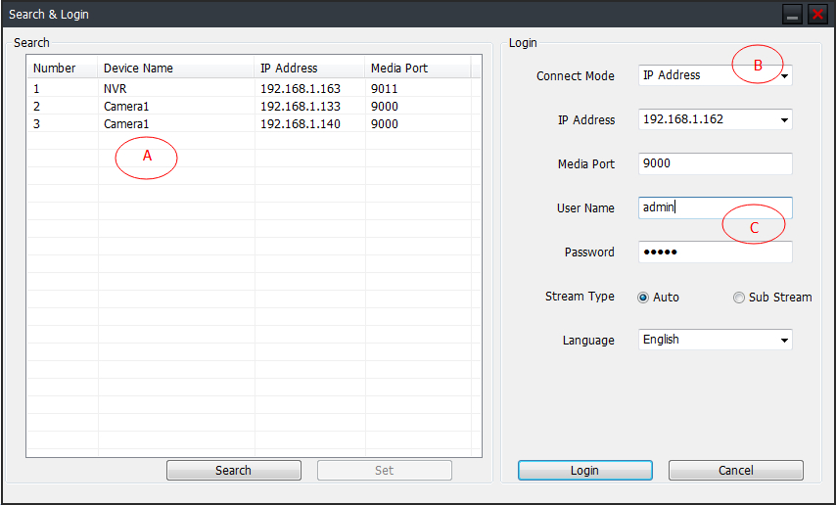

A: IP list for all the IP cameras and NVR connected to the router.
B: Connect Mode: IP Address, Domain Name, or UID.
When logging in for the first time, please choose IP Address, and then click the search button, then click on the IP that appears. The default media port is 9000.
C: The default login information is below.
username: admin
password:12345

Click the Login button to show the camera’s live view stream.

NVR Camera Setup
- After you’ve connected the camera to your NVR, the camera will be automatically detected and assigned an IP address when you turn on your NVR. If the camera is not detected, check that the Ethernet cable is inserted correctly.
- Provided if all network connections have been correctly set up, the camera should automatically appear on-screen shortly after being plugged in. Cameras are assigned to the first available channel by your NVR in this case, regardless of which Network Camera port that it was connected to. You can still, however, display the camera on a different channel. Please consult your NVR’s user manual for an explanation on how to assign cameras to available channels.
- To reset the camera:
  - Unplug the Ethernet cable from the camera’s network port, then press and hold the reset button. While holding the reset button, plug the Ethernet cable back into the camera’s network port.

Note:
- For a detailed operational introduction, please refer to our CD included in your package for the electronic version of the User Manual.
- This quick start guide is for reference only. Slight differences may be found in the user interface.
- All the designs and software here are subject to change without prior written notice.
- All trademarks and registered trademarks mentionedare the properties of their respective owners.
- If you have any questions or concerns, please contact us at support@qcam.com, or visit http://qcam.com/support.

